Omiga Development Process

Development process definition for the Omiga & Omiga Supervisor development projects

Mark Gwilliam
Mortgage Software Development
Version 0.2
8th October 2007

For Circulation to:

Andy Green | Omiga Technology Refresh Project Manager

© Vertex Financial Services Ltd 2007

The contents of this report are the copyright of Vertex Financial Services Ltd and all rights reserved. No part of this document may be reproduced, stored in a retrieval system or transmitted, in any form or by any means electronic, mechanical, recording or otherwise, without the prior written consent of the copyright owner.
Document Control

Change Record

Date | Author | Version | Change Reference
18/9/2007 | Mark Gwilliam | 0.1 | Initial draft
8/10/2007 | Mark Gwilliam | 0.2 | Revised following review with Rob Hart  Altered overall document format

Reviewers

Name | Position/Company

Contents
Introduction 4
Purpose 4
Audience 4
The Process 5
Overview 5
Artefacts 6
Team Roles 10
Environments 12
Development (local) 12
Development (shared) 12
System / functional testing 13
Load and integration testing 13
Acceptance / Production 13
Quality Plan 14
Traceability 14
Handover 14
Review 15
Patterns 15
Code commenting 15
Continuous integration (CI) 15
Unit testing 15
Versioning 16
Decision logging 16
Developer workflow overviews 17
Prototyping 17
Feature building 17
Defect fixing 17
Reworking 18
Core Tools 19
References 20
SQL standards 20
C# coding standards 20
Useful web links 20
NOTES (to be removed from final version) 21

Figures
Figure 1 Process Overview 5
Figure 2 Environments Overview 12
Figure 3 Artefact Traceability 14

Introduction

Purpose
This document defines the process, roles, artefacts and workflows for those participating in the development of the Omiga Supervisor project

Audience
This document should be used as a reference for the following team roles:

- Analyst
- Architect
- Configuration manager
- Database developer
- Designer
- Developer
- Project manager
- Tester

The Process

Overview
The development process is broadly based on the Agile Unified Process. The process will emphasize the following key drivers:

- Iterative development
- Quality
- Team collaboration
- Agility

A graphical overview of the process:

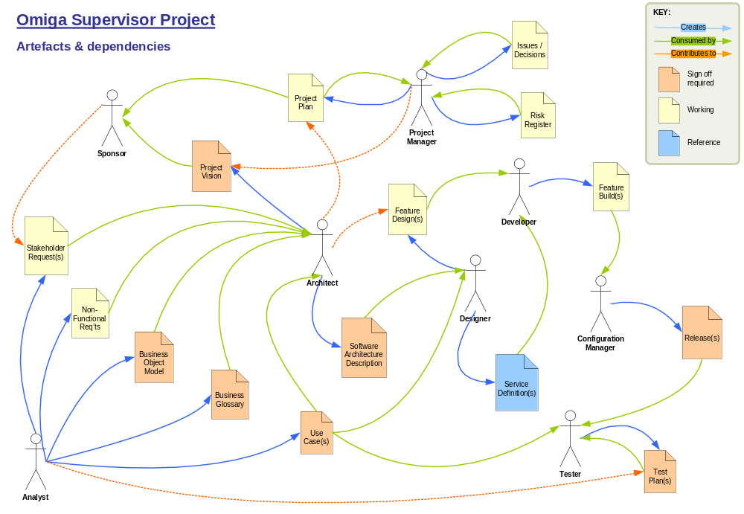
Figure 1 Process Overview

The diagram above shows the following key points:

- Team roles
- Artefacts
- Artefact owners
- Artefact consumers
- Artefact contributors

Artefacts
An artefact is defined as an output that is produced and consumed during the project lifecycle and contributes towards the ultimate goal of delivering the end solution. Artefacts should satisfy the following criteria – if not then the production of the artefact should be challenged:

- Each artefact should have a clearly defined purpose
The artefact should clearly fit within the overall project lifecycle and have a defined producer and consumer from the list of team roles

- Each artefact should add value to the project

- Each artefact should be fit for the above purpose / consumption
The completed artefact should be deemed as acceptable by the artefact consumer

Artefacts can be categorised as:

Working | Transient artefact to facilitate the delivery of the project. Typically to hold short-term information or used to assist in the production of another artefact
Requiring sign-off | Forms part of the terms of reference for the project and represents a delivery commitment
Reference | Survives beyond the project delivery and is used for support and extensibility purposes

The following artefacts are produced during the project lifecycle:

- Working:
  - Feature designs
  - Feature implementations (build)
  - Issues / decisions log
  - Non-functional requirements (NFRs)
  - Project plan
  - Risk register
  - Stakeholder requests

- Sign-off:
  - Business glossary
  - Business object model (BOM)
  - Project vision
  - Release builds
  - Software architecture description (SAD)
  - Test plans
  - Use cases

- Reference:
  - Service definitions (SDs)

A brief definition of each artefact follows:

Business glossary
Type: Document

List of business terms used within the project along with a record of synonyms and/or previously used terms

Business object model (BOM)
Type: Diagram and supporting document

Depicts business entities as a conceptual model and how they are related to each other in the context of the project

Feature designs
Type: Diagrams and / or supporting documents

Design artefacts to be used for constructing software features. This may include UML diagrams, descriptive text or any other format of information that describes the intent of the software to be built

Feature implementations
Type: Code, scripts, etc.

Coding artefacts used to build the software

Issues / decisions log
Type: Document / spreadsheet / list

Used to capture and manage issues and mitigating actions. Any key decisions that impact the project in a non-trivial way should be captured and recorded

Non-functional requirements
Type: Document / spreadsheet / list

Captured requirements relating to some or all of the following:

- Capacity
- Concurrency
- Extensibility
- Interoperability
- Legal
- Licensing
- Longevity / strategic compliance
- Maintainability
- Manageability
- Monitoring / instrumentation
- Platform / toolset requirements
- Recoverability
- Reliability
- Response times / latency
- Security
- Throughput / load
- Usability

…plus any known constraints that will impact the solution

Project plan
Type: as determined by toolset

A phased, iterative project plan identifying milestones, high level activities and task dependencies. Current and next iterations are detailed – others are held as feature or use case lists

Project vision
Type: Document

Outlines the purpose, business case, scope and features of the project and identifies dependencies on other projects

Release builds
Type: Software and supporting documentation

Deployable builds for the following environments:

- Development
- Testing
- Production / Release Candidates

A release note should accompany any builds (apart from development builds perhaps)

Risk register
Type: Document / spreadsheet / list

Used to capture, prioritise and manage risks and to document mitigating actions

Service definitions
Type: Document / spreadsheet / list

Documented service definitions for all exposed services in the solution including schemas and usage guidelines. Service definitions should be versioned and issued with a software release

Software architecture description
Type: Diagrams and supporting documentation

Agile version of the SAD as defined by the Unified Process. This may be incorporated into a revision of the Project Vision artefact as opposed to a separate document

Stakeholder requests
Type: Document / spreadsheet / list

High level requirements as captured during a stakeholder meeting. Not all requests will be in the delivery scope for the project

Test plans
Type: as determined by toolset

Defines how the solution will be tested, what will be tested and include test scripts to perform those tests

Use cases
Type: Documentation and supporting diagrams

Documented system interactions from the perspective of the end users (actors). Use Case diagrams may be used to represent the system functionality in a wider context

Team Roles
The following team roles participate in the development process. Note that roles refer to responsibility and expectation and do not necessarily indicate individuals:

Analyst
Main responsibility: requirements capture and analysis

Creates:
- Stakeholder requests
- Non-functional requirements
- Business object model
- Glossary
- Use cases

Architect
Main responsibility: technical design authority

Creates:
- Project vision
- Software architecture description

Configuration manager
Main responsibility: builds

Creates:
- Releases

Database developer
Main responsibility: database development

Creates:
- Schema
- Stored procedures
- Data migration
- Change scripts

Designer
Main responsibility: software design

Creates:
- Design artefacts
- Design specifications
- Service definitions

Developer
Main responsibility: coding

Creates:
- Feature implementations

Project manager
Main responsibility: project delivery

Creates:
- Project plan
- Risk register
- Issues log
- Decisions log

Sponsor
Main responsibility: customer

Tester
Main responsibility: software testing

Creates:
- Test plans
- Test scripts
- Defects

Environments
The following environments should be created and managed. These environments are intended to provide “gates” on the route to production and mitigate any risks prior to deployment to the production environment. Functional and non-functional requirements should be tested as early as possible in the environment chain

Virtual machines can be used up to (and including) the system test environment

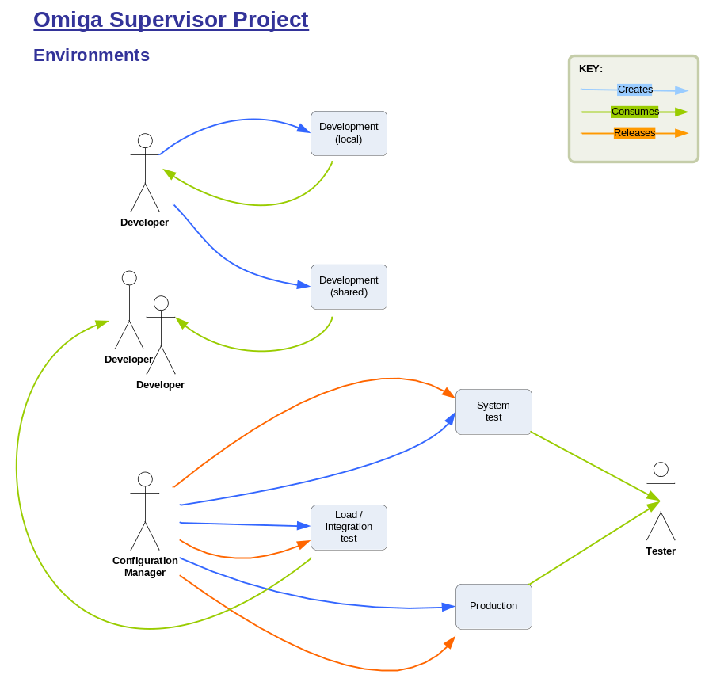
Figure 2 Environments Overview

Development (local)
This environment exists on a developer’s own machine and is used exclusively by that individual. It should be used for local coding and unit testing prior to check-in

- Deployment to this environment is on an ad-hoc basis

Development (shared)
This environment is used by multiple developers prior to deployment to system testing. Its purpose is to verify design and configuration when moving to a multi-tier environment. The environment is owned by the development team

- Artificial load testing should be performed
- Deployment to this environment is on an ad-hoc basis as decided by the development team

System / functional testing
The main functional testing environment used to determine suitability of the solution from a functional perspective. Defects should be raised by system testers and fed back to the development team

- Dual environments are recommended to avoid downtime between code drops. Build verification tests (BVTs) should be run on each test environment to ascertain suitability prior to release to the test team
- Deployment to this environment is on a regular basis (typically weekly or bi-weekly)

Load and integration testing
This environment should resemble the production environment as closely as possible in terms of hardware and software

As the final pre-production environment, this should be used to ensure that components can be deployed and co-exist with other software

- Load testing should be performed
- Deployment instructions (as defined in the release note) should be followed as a dry run for the production deployment
- Deployment to this environment should be approximately towards the end of each iteration

Acceptance / Production
The final environment will depend on the nature of the project

- Some post-deployment testing should be performed to verify the deployment has been successful. This testing need not be extensive but should verify that all application layers are communicating as intended and that all configuration is correct

Quality Plan
The team as a whole is responsible for producing a quality product. The following steps should be adhered to so that a high level of quality is maintained:

Traceability
To reduce the risk of introducing redundancy and also to assist with impact assessment of future change, artefacts should be traceable to parent artefacts. For example:

- Use cases should be traceable to stakeholder requests
- Designs should be traceable to analysis
- Code should be traceable to designs
- Code fixes should be traceable to defects
- …and so on

The most significant traces are shown in the diagram below:

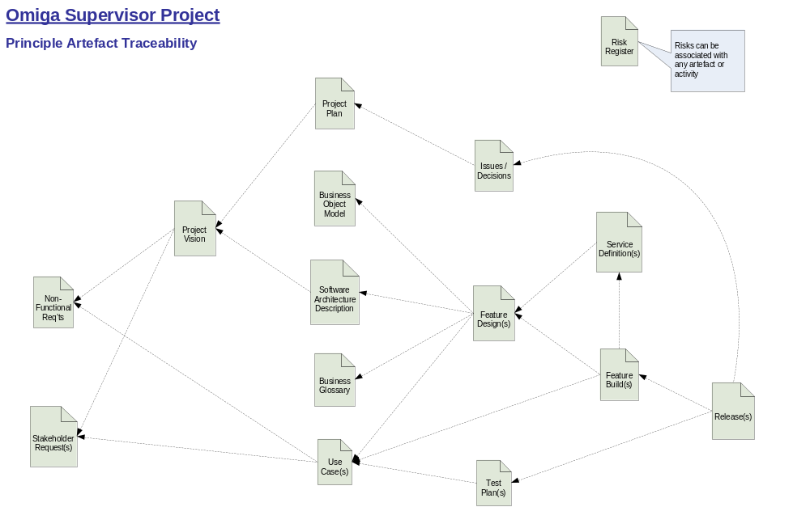
Figure 3 Artefact Traceability

Handover
Artefacts should be fit for purpose and deemed acceptable by the individual(s) for which the artefact has been created

Formal signoff is to be discouraged where possible within the team. If an associated work item exists in the tracking system then the handover should be recorded against that item

Review
Where appropriate, a review should follow implementation. The individual that issued an artefact during handover should ensure that the work item has been implemented correctly

As above, formal signoff is to be discouraged where possible within the team. If an associated work item exists in the tracking system then the handover should be recorded against that item

Patterns
The use of established design patterns should be encouraged where appropriate. In these cases the name of the pattern(s) used should be included in the design / implementation code

Code commenting
Commenting should be used liberally in source code to assist future maintenance and understanding. Such comments should specify the intention of the code as well as explaining how this intention is realised

Continuous integration (CI)
Continuous integration should be used to mitigate against code regression and defect introduction. In larger projects, a build pipleline should be introduced to maintain rapid CI builds

Unit testing

Types of unit test
Unit tests should be used in the following scenarios:

- Feature build
  - Positive tests to verify behaviour under correct usage
  - Negative tests to verify behaviour under failure conditions

- Load tests should be created to prove the capacity and response times of the solution as defined in the non-functional requirements

- Deployment / Build Verification Tests (BVT) should be used to ascertain that a deployment can be released to system test

- Code refactoring must include unit tests to ensure behaviour is not adversely impacted – i.e. to guard against introducing defects

- Defects should be reproduced in a development environment and a unit test created to produce the failure. Fixing the defect should result in the associated unit test passing

- External dependencies. When consuming a component that has been created outside the project team, tests should be devised to guard against regression and highlight any changes in behaviour of the component

Test coverage
As a goal, unit tests should aim to cover all code paths at least once

Versioning
All builds should include application of a label to the source with the exception of continuous integration builds

Decision logging
All decisions that shape the project in any way should be recorded in the decision log with appropriate supporting materials

Developer workflow overviews
Distinct workflows apply to developers and show the difference in working practice based on the following activities:

- Prototyping
- Feature building
- Defect fixing
- Reworking

Prototyping
Trigger: to prove or disprove a technology, principle or mitigate some other risk – typically under the direction of the architect and/or designer

Steps:
- Architect defines prototype requirement / purpose
- Architect and Senior Developer agree constraints (e.g. technologies)
- Developer(s) implements prototype(s)
- Prototype(s) reviewed by Architect and Senior Developer
- Architectural decisions / lessons learned should be documented

Feature building
Trigger: a unit of work has been identified based on the architectural or functional build requirement for the current iteration

Tracking:
- A work item is created to represent the item(s) being built

Steps:
- Architect / Project Manager schedules feature
- Architect / Designer designs solution
- Analyst / Architect reviews design
- Designer hands over design to Senior Developer
- Developer(s) implements design(s)
- Senior Developer / Designer reviews implementation
- Senior Developer notifies Project Manager feature has been built
- Feature is incorporated into next system test build
- Tester is notified of feature availability for test

Defect fixing
Trigger: in response to a defect been detected during testing

Tracking:
- A defect item is created to represent the defect

Steps:
- Tester identifies defect
- Tester raises defect in defect tracking system
- Architect / Analyst verifies defect
- Architect notifies Project Manager of defect
- Project Manager schedules fix according to priority and severity
- Project Manager allocates defect
- Developer confirms understanding of defect with Tester
- Developer implements fix
- Senior Developer reviews fix
- Senior Developer notifies Project Manager fix has been implemented
- Fix is incorporated into next system test build
- Tester is notified of fix availability for retest (in release note)

Reworking
Trigger: either as a result of a design change or a change request

Tracking:
- A work item is created to represent the rework

Steps:
- Architect / Designer performs initial impact assessment
- Project Manager approves rework
- Designer designs solution
- Architect reviews design
- Architect / Designer provides detailed impact assessment
- Project Manager schedules rework
- Designer hands over design to senior developer
- Developer(s) implements design(s)
- Senior Developer / Designer reviews implementation
- Senior Developer notifies Project Manager rework has been implemented
- Rework is incorporated into next system test build
- Tester is notified of rework availability for retest

Core Tools
The following core tools are used in the development process. Additional tools should be adopted where appropriate and shared with other team members

Activity / artefact | Tools | Licensing
Automated builds | Nant / MSBuild  Microsoft Team System | Open source / Free  Paid
Coding | Microsoft Visual Studio 2005  Microsoft Team System | Paid
Continuous integration | CruiseControl.NET  Microsoft Team System | Open source / Free  Paid
Database development | Microsoft SQL Server 2005  Microsoft SQL Server Express  (developer’s machines) | Paid  Free
Defect tracking | Microsoft Team System | Paid
Diagramming / modelling | Microsoft Visio, whiteboards | Paid
General documentation | Microsoft Office | Paid
Issues list | Microsoft SharePoint  Microsoft Team System | Paid
Project planning | Microsoft Project | Paid
Project portal / information access | Microsoft SharePoint  Microsoft Team System | Paid
Release builds | Final Builder | Paid
Risk register | Microsoft SharePoint  Microsoft Team System | Paid
Source control / repository | Microsoft VSS  Rational Clear Case  Microsoft Team System | Paid
Unit test coverage | NCover  Microsoft Team System | Open source / Free  Paid
Unit testing | NUnit framework  Microsoft Team System | Open source / Free  Paid
Use case documents | Microsoft Word | Paid
Work item tracking | Microsoft Project  Microsoft Team System | Paid

References

SQL standards
SQL standards are defined in the following document:

TODO: Reference

C# coding standards
C# coding standards can be found on MSDN:

http://msdn2.microsoft.com/en-us/library/ms229042.aspx
TODO: add VFS / MSD link

Useful web links
Product information:

TODO: Team System and any other tools

Tools:

http://www.nunit.org/
http://ncover.org/site/
http://sourceforge.net/projects/nant/
http://sourceforge.net/projects/ccnet/ (CruiseControl.NET)
http://www.testdriven.net/
http://www.gotdotnet.com/Team/FxCop/

Links to relevant background material for terms in this document:

http://en.wikipedia.org/wiki/Agile_Unified_Process
http://en.wikipedia.org/wiki/Unified_Process
http://en.wikipedia.org/wiki/Design_patterns
http://en.wikipedia.org/wiki/Test_driven_development
http://en.wikipedia.org/wiki/Refactoring

NOTES (to be removed from final version)
Other documents / sections

- Defect process (will depend on toolset)
- Technical environment(s): all databases, servers, config settings etc.
- Build process

